Creating Equal: How Benjamin Banneker Challenged Jefferson on Race and Freedom
When the Bill of Rights was adopted in 1791, the liberties it provided were withheld from the hundreds of thousands of Africans living here in slavery. That same year, a free African-American, Benjamin Banneker, challenged the way blacks were seen and treated by whites in America in a public letter to Thomas Jefferson. In this letter, Banneker pointed to the contradictions between the principles laid out in the Declaration of Independence and Bill of Rights, and the continued existence of slavery.
In courteous but forceful words, Banneker called on one of Jefferson’s own great Enlightenment principles, an ideal that intimately tied together liberty and faith in a democracy—the idea that God creates all men equal:
That one universal Father hath given being to us all; and that he hath not only made us all of one flesh, but that he hath also, without partiality, afforded us all the same sensations and endowed us all with the same faculties; and that however variable we may be in society or religion, however diversified in situation or color, we are all of the same family, and stand in the same relation to him.
Early in Jefferson’s political career, he made some attempts to gradually end slavery in the United States. But despite Jefferson’s misgivings about the slave trade, he continued to believe in the moral and social superiority of whites over blacks. In fact, he personally owned and sold upwards of 700 slaves. Meanwhile, in his famous Notes on the State of Virginia (1781), Jefferson condemned slavery itself, but reiterated the idea of blacks’ physical and intellectual inferiority to whites:

I advance it, therefore, as a suspicion only, that the blacks, whether originally a distinct race, or made distinct by time and circumstance, are inferior to the whites in the endowment both of body and mind.
Jefferson then went on to write disparagingly of the physical appearance of blacks and witheringly dismissed the intellectual and creative potential of the entire race:
Comparing them by their faculties of memory, reason, and imagination, it appears to me, that in memory they are equal to the whites; in reason much inferior . . . and that in imagination they are dull, tasteless, and anomalous . . . But never yet could I find that a black had uttered a thought above the level of plain narration; never see even an elementary trait, of painting or sculpture.
In the light of such passages, Benjamin Banneker’s decision to take up his pen and address Jefferson with a plea for a change of heart might have seemed like an extraordinary, and potentially risky, gesture. He began:
SIR, I AM fully sensible of the greatness of that freedom, which I take with you on the present occasion; a liberty which seemed to me scarcely allowable, when I reflected on that distinguished and dignified station in which you stand, and the almost general prejudice and prepossession, which is so prevalent in the world against those of my complexion.
But Banneker had carefully thought through why he was the right person to address Jefferson, and why Jefferson was the right leader to whom he should make his plea. He enclosed a copy of the popular astronomical almanac he had authored, and mentioned in passing his employment on the survey of the District of Columbia, Banneker added:
Sir, I freely and cheerfully acknowledge, that I am of the African race, and in that color which is natural to them of the deepest dye; and it is under a sense of the most profound gratitude to the Supreme Ruler of the Universe, that I now confess to you, that I am not under that state of tyranny, and inhuman captivity, to which too many of my brethren are doomed, but that I have abundantly tasted of the fruition of those blessings, which proceed from that free and unequalled liberty with which you are favored; and which, I hope, you will willingly allow you have mercifully received, from the immediate hand of that Being, from whom proceeded every good and perfect Gift.
In other words, Banneker suggested that his own achievements as a freeman were both a contradiction of Jefferson’s belief that blacks innately lacked intellectual ability, and proof of what they could achieve when they were not limited by the “tyranny” of slavery. He reminded Jefferson of the very language of religious humility that the Secretary himself had used elsewhere—the idea that the blessings of liberty come from a Supreme Being, rather than being doled out by one human being to another. Banneker hoped to get Jefferson to take that principle further and to accept that the same ideal applied to people of all races.
Less than two weeks after receiving Banneker’s letter, Jefferson sent him a polite response (dated August 30, 1791). In it, he appears to extend Banneker his good will. Discussing “the degraded condition” of blacks in African and America, the short letter even seems to suggest that Jefferson might change his own views about race:
No body wishes more than I do, to see such proofs as you exhibit, that nature has given to our black brethren talents equal to those of the other colors of men; and that the appearance of the want of them, owes merely to the degraded condition of their existence, both in Africa and America.
Unfortunately, Jefferson’s reply fell far short of addressing the political, religious, and ethical challenges that Banneker had put forth. The engineer had written:
Sir, how pitiable is it to reflect, that although you were so fully convinced of the benevolence of the Father of Mankind, and of his equal and impartial distribution of these rights and privileges, which he hath conferred upon them, that you should at the same time counteract his mercies, in detaining by fraud and violence so numerous a part of my brethren, under groaning captivity and cruel oppression, that you should at the same time be found guilty of that most criminal act, which you professedly detested in others, with respect to yourselves.
It was a question which the future president chose not to debate with the freeman: the fundamental contradiction between the principles of democracy and freedom and the cruelty of slavery, voiced by Banneker.
Jefferson, it seems, saw Banneker’s intelligence as an exception among African-Americans, rather than evidence that Jefferson’s perceptions about race might be fundamentally flawed. Sadly, three years after Banneker’s death in 1806, Jefferson wrote to Joel Barlow, an American poet and politician, disparaging the by-then well known Banneker and arguing that he could not have made the calculations contained in the almanac without assistance. With time, he had convinced himself that the “proofs” of ability he had once seen in Banneker could not be real.
Banneker, however, may have had more then one purpose in crafting his plea to the Jefferson. In 1793, he had the letters between Jefferson and himself printed in his annual almanac. These periodicals contained not only tables of tides and weather, planetary cycles and astronomical calculations, but also essays and poetry by the African American poet Phillis Wheatley and the English anti-slavery poet William Cowper, and anti-slavery speeches and essays from England and America. They were supported and circulated by Banneker’s Quaker allies, the Ellicott family, and by Society for the Promotion of the Abolition of Slavery of Maryland and of Pennsylvania. The pamphlets circulated as far as Great Britain, where the famed anti-slavery campaigner William Wilberforce praised Banneker in the House of Commons.
Banneker, then, not only embodied the principles of those who argued for an end to slavery in his achievements, but worked actively to influence public opinion in favor of abolition. Like Washington’s outreach to the Jews of Newport, Banneker’s address to Jefferson belongs to the great tradition of public letters. Through the freedom of the press, circulating his writings within a country eager for political debate, Banneker could craft his own appeal to public opinion and claim some of Jefferson’s most powerful ideas for the cause of African-Americans seeking freedom—even where one of the Founding Fathers far fell short of those ideals.
Name Date
Banneker and Jefferson Text Thread

Expectations: Using the reading, please translate what the two men were saying into a text thread.

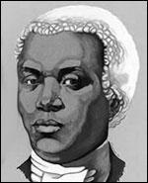

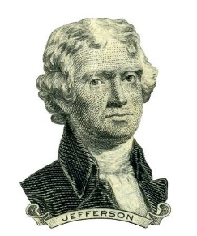

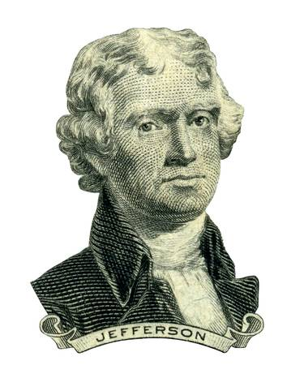

What was Banneker’s main argument against slavery after the American Revolution?

