Name_________________________________ 7th Grade Ancient Civilizations (Key Assignment)

Design Your Own Ideal Civilization Rubric

Objective: Your task is to create your own original, ideal, and new civilization using the information that we have learned about the following: Mesopotamia, Persia, ancient Egypt, ancient China, Hebrews, and Indus River Valley.

*Your finished product may be in any presentation format (poster, PowerPoint, PREZI, Photo Story, etc.).
In addition, you MUST cite any sources that you’ve referred to other than your Ancient Civilizations textbook and class handouts provided by Mr. Knauss.

*If you print pictures from a credible, appropriate website, then you MUST cite the exact website from which you found the picture(s). You may not just use “google images” as your citation since that is just a search engine; not a website. It will result in a deduction of 1 point for each outside source used and/or picture from the Internet that is not cited.

If you incorporate any components of a specific civilization learned about, then you must include which one you modeled.

___/3 Part 1: Name of your civilization
- What is the name of your civilization? ___/1
- Why did you decide on this name? How did you come up with it? ___/2

___/10 Part 2: Natural boundaries and territories.
- Where is your civilization located in the world? (City, Country) ___/2
- Describe the climate of your civilization. ___/2
- Describe the landscape of your civilization. ___/2
- What parts of the land and/or coastlines make your culture easy to attack? ___/2
- What defenses does the land provide naturally? ___/2

___/10 Part 3: Social Structure
Create a pyramid that shows the class divisions in your society. (Example of pyramid structure)
- Label the levels of the pyramid. ___/4
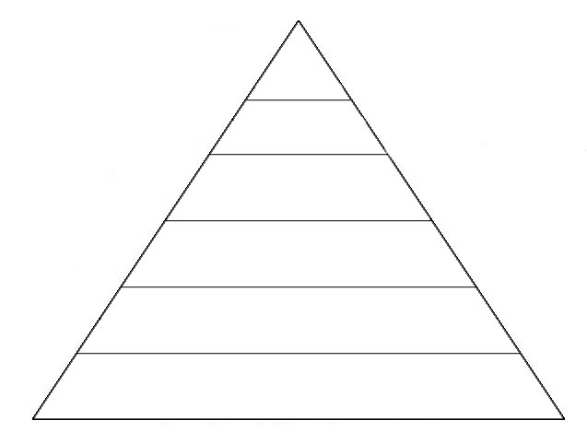
- Explain which groups of people are included in each division. ___/4
- Include specific jobs for each division of class. ___/2

___/20 Part 4: Government and Laws
Describe the organized government of your civilization.
- What form of government does your culture have? ___/2
2. How are the leaders selected? ___/2
3. What are the titles of those in power? (Ex. President, king, ruler, all mighty one) ___/2
4. What are the responsibilities of those in power? (at least 4 responsibilities) ___/4
5. What major laws have been made and why? (at least one minor and one severe) ___/4
6. What punishments exist for law breakers according to your laws? ___/4
7. Explain your form of military. (foot soldiers, navy, etc.) ___/2

___/10 Part 5: Religion
Describe the religion of your civilization.
- Is your civilization polytheistic or monotheistic? ___/2
- Who is considered to be your religious leader(s)? ___/1
- Which god is/god(s) are worshipped by the people in this civilization? ___/2
4. How do the people show respect for their god(s)? ___/2
5. Describe the most important religious holiday or ceremony in your culture. Tell what it is
and explain how people in your civilization celebrate it. ___/3

___/10 Part 6: Language
1. What is the name of the language your civilization speaks? ___/3
- Explain whether your language is represented by symbols, pictures, letters, or a
combination of some or all above? ___/2
- Create a writing sample that your civilization has created. ___/5

___/9 Part 7: Economics
Describe the economic system in your civilization.
- What is your type of currency? ___/1
- Explain at least four factors that have an effect on your economy. ___/8

___/20 Part 8: Arts, Literature, Customs, and Traditions
Describe components of art, literature, customs, and traditions in your civilization.

Create a picture collage of artifacts within your civilization that represent art, literature, science, and math. Examples include (but are not limited to): jewelry, games, dance, musical instruments, architecture, clothing, or sports.

*You must incorporate at least 10 different artifacts, all from different categories definitely incorporating art and literature. (Some examples of categories provided above).

___/8 Part 9: Contributions
Describe contributions of your civilization. (These are things your civilization created for the world that are NOT part of the artifacts mentioned for arts, literature, customs, and traditions.)
For example: The ancient Egyptians created paper that we still use today.

You are to create a picture display of the major inventions your civilization created including the following:
- at least four inventions labeled (4 points)
- an image of each invention (2 points)
- description of its use (2 points)

___/100 TOTAL POINTS

